Building a model of a Wetland

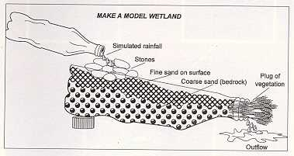
Step 1:
Involve the learners in the building of the wetland model. Intermediate or Senior Phase learners can be divided into smaller groups so that they can all build their own models within their groups, with you as educator assisting them. In the case of Foundation Phase learners you will have to build the model, with them assisting you.

You will need the following: an empty 2 litre bottle cut in half along the length of the bottle, coarse sand, fine sand, a few small rocks, a few grass clippings and the lid of the bottle. Now build the model in the following way.

- Cut the 2 litre bottle in half along the length without damaging the neck of the bottle.
- Plug the neck of the bottle with grass clippings.
- Fill bottom of the bottle with the coarse sand.
- Put a layer of fine sand on top of the coarse sand.
- Pack the stones in a little heap near to the fat end of the bottle.
- Now put the fat end of the bottle on top of the lid of the bottle and rest the neck of the bottle in a little bowl in such a way that the bottle is at an angle going down towards the neck. The bottle has to be at an angle so that the water will run down from the fat end towards the neck of the bottle and into the bowl.
- Now your wetland model is ready for operation.

Step 2:
Slowly pour water over the rocks in the "wetland". Watch through the see-through sides of the bottle to see what happens. See how the water level in the sand rises. This can be compared to groundwater in a real wetland. Measure the time from when the water is poured over the rocks until it flows out of the bottle into the little bowl. Can you see that this takes much longer than it would have taken if the water just ran along the surface of the sand to the bowl.

Step 3:
Now mix water in a see-through container with dirt until the water is murky and muddy. Slowly pour the murky water over the stones in the "wetland". Keep a little bit behind in the container. Wait until the water has moved through the soil and flowed into the little bowl underneath the neck of the bottle. What is the colour of the water? Compare it to the colour of the murky, muddy water left behind in the see-through container.

Step 4:
In which ways do you think wetlands are useful?

